Project Design Phase-II
Data Flow Diagram & User Stories

Date | 5 September 2026
Team ID | SWUID2026190376
Project Name | Metro Ticket Generating System in ServiceNow
Maximum Marks | 4 Marks

Data Flow Diagrams:
A Data Flow Diagram (DFD) is a traditional visual representation of the information flows within a system. A neat and clear DFD can depict the right amount of the system requirement graphically. It shows how data enters and leaves the system, what changes the information, and where data is stored.
DFD Level 0 – Metro Ticket Generating System
Example: DFD Level 0 (Industry Standard)
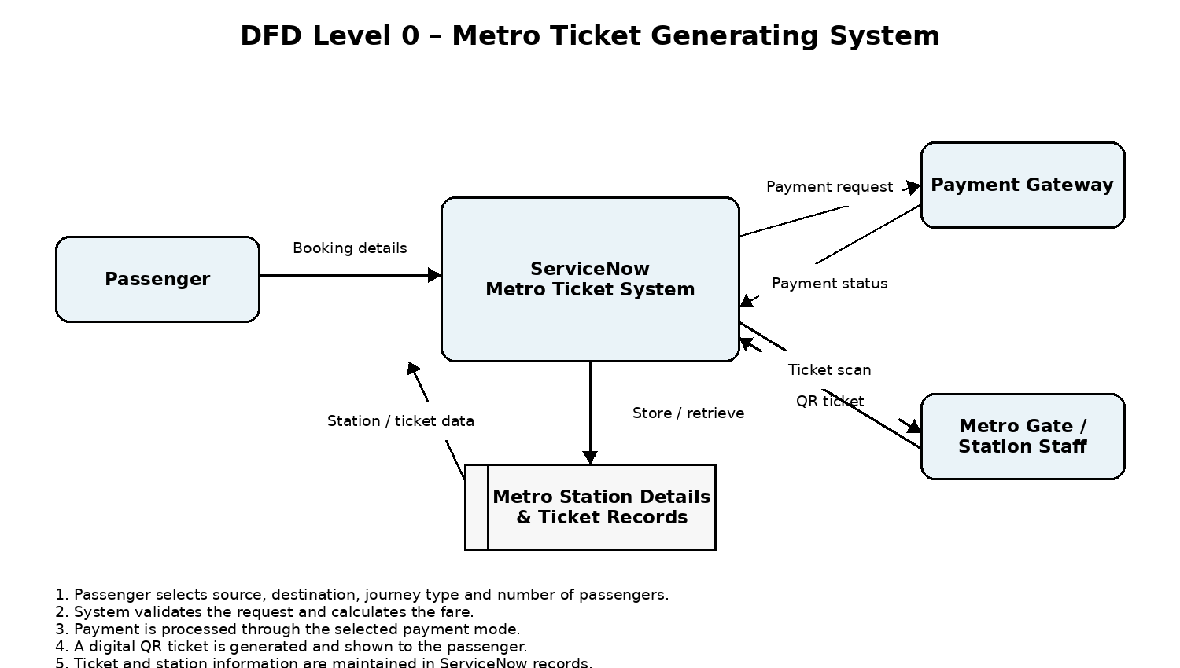

User Stories
Use the below template to list all the user stories for the product.
User Type | Functional Requirement (Epic) | User Story Number | User Story / Task | Acceptance criteria | Priority | Release
Passenger | Ticket Booking | USN-1 | As a passenger, I can select my starting station and destination station to book a metro ticket. | I can select valid source and destination stations. | High | Sprint-1
 | Journey Selection | USN-2 | As a passenger, I can choose Single Journey or Return Journey. | The selected journey type is stored correctly. | High | Sprint-1
 | Passenger Details | USN-3 | As a passenger, I can select the number of passengers for the ticket. | I can select the required number of passengers and continue booking. | High | Sprint-1
 | Fare Calculation | USN-4 | As a passenger, I can see the fare calculated automatically for my selected journey and passengers. | The system calculates and displays the correct payable amount. | High | Sprint-1
 | Payment | USN-5 | As a passenger, I can select a payment mode such as UPI, Card, or Others. | The selected payment mode is captured with the ticket request. | High | Sprint-2
 | Ticket Generation | USN-6 | As a passenger, I can submit my booking request and receive a digital metro ticket. | A ticket request is created successfully after submission. | High | Sprint-2
 | QR Code | USN-7 | As a passenger, I can view a QR code for my metro ticket. | A QR code is displayed for the generated ticket and can be scanned at the gate. | High | Sprint-2
Metro Station Staff | Station Details | USN-8 | As station staff, I can maintain metro station details used for ticket booking. | Station records are available and can be maintained in ServiceNow. | Medium | Sprint-2
Administrator | Access Control | USN-9 | As an administrator, I can manage access to metro station and ticket-related records. | Only authorized users can perform permitted record operations. | Medium | Sprint-3
Administrator | Deployment | USN-10 | As an administrator, I can package the completed project configuration in an Update Set. | The Update Set contains the required project configuration for deployment. | Medium | Sprint-3

